INTERVIEW
DR. EMILY BASHAH, LICENSED PSYCHOLOGIST, &
HONORABLE PAUL JOHNSON, FORMER MAYOR OF PHOENIX

Authors of Addictive Ideologies: Finding Meaning and Agency When Politics Fail You

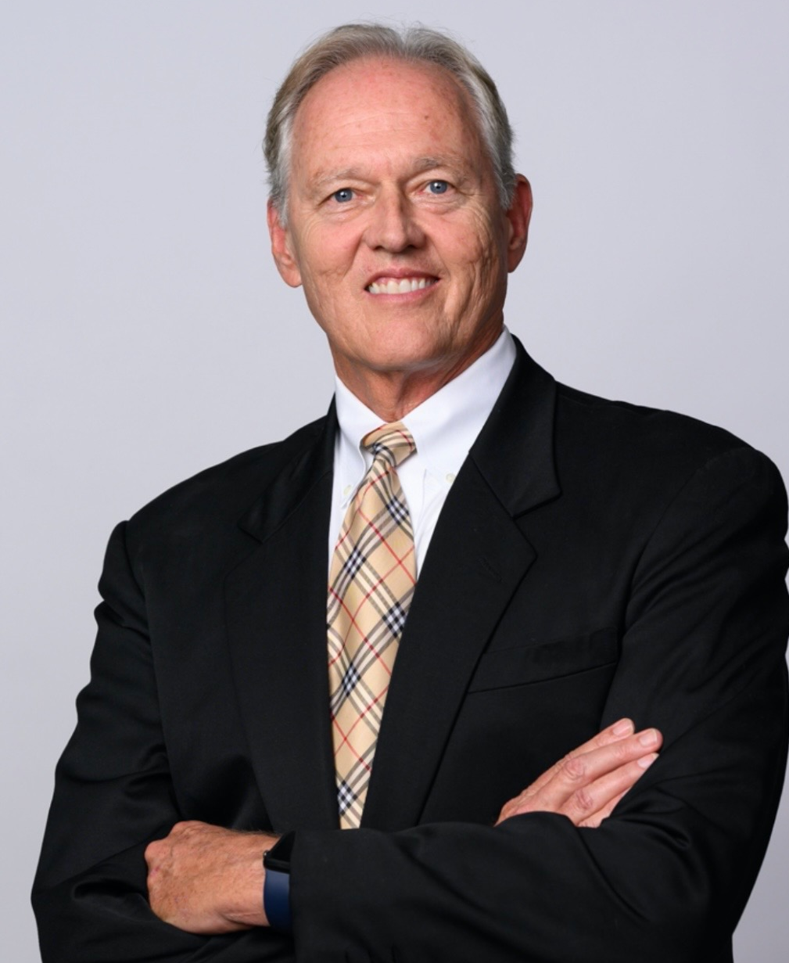

“There are many causes of addictive ideologies—economic loss or hardship, embarrassment, loss of self-esteem or loss of identity. Ideologies can become a logical answer that absolves us of our responsibility for ourselves. Nothing makes an ideology more sticky than the feeling of invisibility.” – Dr. Emily Bashah & Hon. Paul Johnson

BIOGRAPHIES
DR. EMILY BASHAH is an author and licensed psychologist with a private practice in Scottsdale, Arizona. An expert witness in criminal, immigration and civil courts, she has worked on high-profile cases covering issues of domestic terrorism and capital offenses, and first-degree murder.
Dr. Bashah was awarded the Society for the Psychological Study of Social Issues Policy Fellowship and served within the American Psychological Association’s Public Interest Government Relations Office in Washington, D.C. A frequent expert guest in media, Dr. Bashah clinically specializes in mental illness, personal and collective trauma, addiction and grief and loss, as well as family and relationship dynamics. She is the co-author with the Honorable Paul E. Johnson Jr. of Addictive Ideologies: Finding Meaning in Agency When Politics Fail You.
HON. PAUL E. JOHNSON JR. is the host of The Optimistic American podcast, whose goal is to create space in the news media for a positive and hopeful view of America. He has a significant background in business, politics, and government and became the youngest mayor of Phoenix, Arizona at 30 years old. He has managed several state campaigns for presidential candidates and is the CEO and co-founder of Redirect Health.
Emily and Paul’s collaboration in life and work marry their combined skills and backgrounds in clinical and forensic psychology, politics, and geopolitical issues. They address the problems of addictive ideologies to the self and to society while offering insight and wisdom for healing, growth, and transformation. They believe collaborating towards a worthy purpose is essential to unleashing the power of the human spirit. He is the co-author with Dr. Emily Bashah of Addictive Ideologies: Finding Meaning in Agency When Politics Fail You.

ABOUT THE BOOK

Addictive Ideologies: Finding Meaning and Agency When Politics Fail You
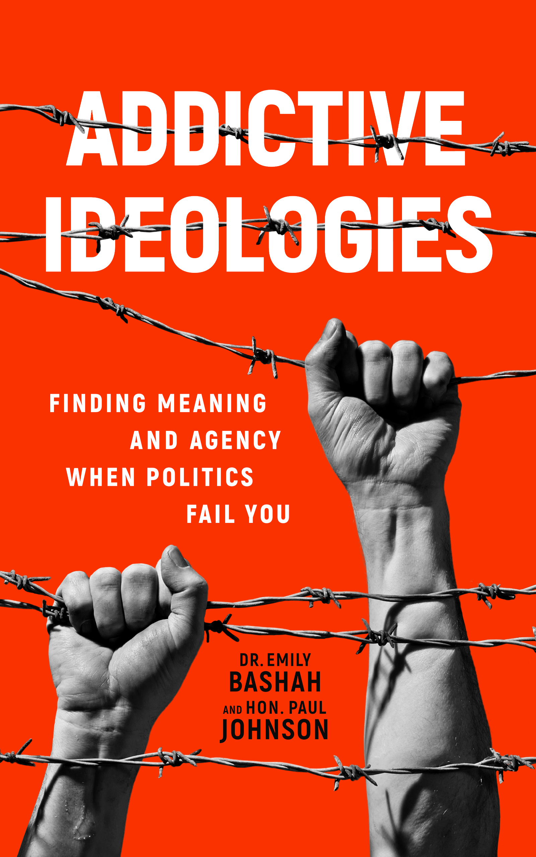
While the news media, politicians, both political parties and conspiracy theory groups are destabilizing America, we often lose sight of how we unwittingly contribute to the hysteria as individuals. In the process, we lose our ability to find optimism, opportunities and meaning. Fortunately, it is still possible to learn from history and to regain one’s agency, self-empowerment and life purpose.
In Addictive Ideologies: Finding Meaning and Agency When Politics Fail You, Dr. Emily Bashah, a clinical psychologist, and Hon. Paul Johnson, entrepreneur and former mayor of Phoenix, Arizona, offer a word of caution. Their belief—that today’s world of runaway identity politics, nationalism and cancel culture is setting the stage for a loss of individual agency and liberty—keenly shows why we can’t take democracy and civility for granted.
Dr. Bashah tells the harrowing story of the persecution of Jews in Iraq by Saddam Hussein and the Ba’ath Party through her family’s own personal experiences. Building on Dr. Bashah’s powerful historical context, Hon. Paul Johnson uses his own mayoral experiences to chart a path for the future that can avoid similar atrocities. This book draws upon an understanding of societal divisions and clinical and social psychology to show the real power we have to promote constructive change.
By merging insights from two widely disparate worldviews, Dr. Bashah and Hon. Paul Johnson show that genocide isn’t the result of just a few bad men, and tyranny isn’t only caused by one charismatic leader. Both require hundreds of thousands of people to ignore reality, and it’s our responsibility as Americans to stay vigilant so that we can protect our families and loved ones against the myriad dangers of addictive ideology.

INTERVIEWS

Hon. Paul Johnson and Dr. Emily Bashah are available for expert commentary, interviews, articles and more on topics such as:

- How authoritarians come into power and why ideologies sometimes lead to violence
- How Dr. Bashah’s family history of persecution and genocide is relevant to what is happening today, and lessons we can take from the past
- How antisemitism can be prevented
- How self-agency and accountability can be promoted?
- Factors that lead to the breakdown of society and the top actions individuals can take to help prevent this breakdown
- How we can stop polarization in the U.S., despite overwhelming divisiveness
- How certain ideologies can become addictive and problematic, and why some people become radicalized
- Tips to help yourself or a loved one who has fallen into the trap of addictive ideologies
- How Americans can be optimistic when surrounded by negative bias, and why this optimism is crucial
- Why and how politicians and news media use negative bias
- The amygdala hijack process and how it impacts politics
- Warning signs that an ideology could lead to genocide or other atrocities
- The psychology of terrorism – why it happens and what can be done to prevent it
- The role that existing political parties are playing in extreme ideologies
- The impact of radical ideologies and extremism from both political sides
- Similarities between woke culture and the Alt Right and why both are dangerous

INDIVIDUAL INTERVIEWS
Other questions that Paul Johnson and Dr. Emily Bashah can respond to as experts in their individual fields

Paul Johnson, as the former mayor of Phoenix, can respond to these frequently asked questions:

- How did you deal with race issues in policing?
- How did you bridge the divide between the right and the left?
- What are political reforms that could help change the divisive problems in America?

Dr. Emily Bashah, as a psychologist, can respond to these topics:

- What can we learn from antisemitism and other forms of oppression when applied to the various race and gender issues we are seeing today?
- What are the risk factors for indoctrination into radicalized groups?
- How can radicalization at an individual level be prevented to stop people from being drawn into extremist groups like radical Islamic terrorist organizations and domestic groups like the “incel” subculture?
- What role can parents play in promoting self-agency, identity development, and protective factors in their children?

CONNECT

To learn more about Dr. Emily Bashah and Hon. Paul Johnson please visit optimisticamerican.com and bashahpsychological.com
and connect on LinkedIn, Facebook, Twitter, Instagram, and TikTok

